Software Requirements Specification (SRS)

ARENA – Online Gaming Tournament Management System



Group Members

Huzaifa Safdar (F2024332099)
Muhammad Rayyan (F2024332059)
Abdul Rehman Younas (F2024332051)

Table of Contents

1. Introduction
1.1 Purpose
1.2 Scope of the System (ARENA)
1.3 Definitions, Acronyms, and Abbreviations
1.4 References
1.5 Overview of the Document

2. Overall Description
2.1 Product Perspective
2.2 Product Functions
2.3 User Classes and Characteristics
2.3.1 Operator
2.3.2 League Owner
2.3.3 Player
2.3.4 Spectator
2.3.5 Advertiser
2.4 Operating Environment
2.5 Design and Implementation Constraints
2.6 User Documentation
2.7 Assumptions and Dependencies

3. System Features (Functional Requirements)

3.1 User Registration and Account Management
3.1.1 Register User
3.1.2 Manage User Accounts
3.1.3 Login and Authentication

3.2 League Management
3.2.1 Define League
3.2.2 Manage League Settings

3.3 Tournament Management
3.3.1 Organise Tournament
3.3.2 Announce Tournament
3.3.3 Apply for Tournament
3.3.4 Process Applications
3.3.5 Kick-off Tournament
3.3.6 Declare Winner and Archive Tournament

3.4 Match Management
3.4.1 Play Match
3.4.2 Monitor Live Matches
3.4.3 View Match Results

3.5 Advertisement Management
3.5.1 Upload Advertisements
3.5.2 Manage Sponsorships
3.5.3 Billing and Payment Handling

3.6 Spectator Features
3.6.1 Browse Tournament History
3.6.2 View Player Statistics
3.6.3 Replay Past Matches

4. External Interface Requirements
4.1 User Interfaces
4.2 Hardware Interfaces
4.3 Software Interfaces
4.4 Communication Interfaces

5. Non-Functional Requirements
5.1 Performance Requirements
5.2 Reliability Requirements
5.3 Usability Requirements
5.4 Scalability Requirements
5.5 Security Requirements
5.6 Legal and Regulatory Requirements

6. Other Requirements
6.1 Database Requirements
6.2 Maintainability
6.3 Portability

7. System Design
7.1 Architectural Design
7.2 High-Level Architecture Components
7.3 Use Case Diagram (Design Perspective)
7.4 Class Design
7.5 Sequence Design
7.6 Database Design
7.7 User Interface Design
7.8 Security Design
7.9 Design Constraints

1. Introduction

1.1 Purpose
This Software Requirements Specification (SRS) document defines the functional and non-functional requirements of the ARENA system. The purpose of this document is to provide a complete and unambiguous description of system behavior for developers, project managers, testers, and stakeholders. It serves as a reference throughout the system development life cycle.

1.2 Scope of the System (ARENA)
ARENA is a web-based platform that provides a unified infrastructure for online games, leagues, and tournaments. It allows players to register and compete, league owners to organize tournaments, spectators to watch matches, and advertisers to promote products. The system aims to reduce duplication of effort by providing reusable components for multiple games and communities.

1.3 Definitions, Acronyms, and Abbreviations
- ARENA: Online gaming tournament management platform
- Operator: Administrator responsible for managing the ARENA system
- League Owner: User who creates and manages leagues and tournaments
- Player: Registered user who participates in matches
- Spectator: User who views matches without registration
- Advertiser: User who uploads and manages advertisements
- SRS: Software Requirements Specification

1.4 References
- ARENA Case Study Document
- Bruegge, B., and Dutoit, A. H., Object-Oriented Software Engineering, Prentice Hall
- IEEE 830 / IEEE 29148 SRS Standard

1.5 Overview of the Document
This document includes an overview of the system, detailed functional requirements, interface requirements, and non-functional requirements. Each section describes a specific aspect of the ARENA system.

2. Overall Description

2.1 Product Perspective
ARENA is a standalone web-based system operating on Unix-based platforms. It integrates modules for user management, league management, tournament execution, match handling, and advertisement services.

2.2 Product Functions
The ARENA system provides the following main functions: - User registration and authentication - League and tournament creation - Match scheduling and execution - Live match viewing - Score and statistics tracking - Advertisement and sponsorship management

2.3 User Classes and Characteristics

2.3.1 Operator
The Operator manages system configuration, installs new games, defines tournament styles, and validates user accounts. Operators have advanced technical knowledge.

2.3.2 League Owner
League Owners create leagues, organize tournaments, approve player applications, and declare winners. They have moderate system knowledge.

2.3.3 Player
Players register in the system, apply for tournaments, and participate in matches. They require a simple and user-friendly interface.

2.3.4 Spectator
Spectators can view live matches, browse tournament results, and view statistics without registration.

2.3.5 Advertiser
Advertisers upload advertisements, sponsor leagues or tournaments, and manage billing and payments.

2.4 Operating Environment
The system operates on Unix-based operating systems and is accessed through web browsers supporting JavaScript, cookies, and Java applets.

2.5 Design and Implementation Constraints
- Administration features are not accessible through the web interface
- System must support low-bandwidth connections
- Extensions must not require modification of existing modules

2.6 User Documentation
User manuals and online help documentation will be provided for all user roles.

2.7 Assumptions and Dependencies
- Users have stable internet access
- Compatible web browsers are available

3. System Features (Functional Requirements)

3.1 User Registration and Account Management

3.1.1 Register User
The system shall allow new users to register as Players or League Owners by providing valid personal information.

3.1.2 Manage User Accounts
The Operator shall approve, modify, or deactivate user accounts.

3.1.3 Login and Authentication
The system shall authenticate users using secure login credentials.

3.2 League Management

3.2.1 Define League
League Owners shall be able to create leagues associated with specific games and tournament styles.

3.2.2 Manage League Settings
League Owners shall update league rules, schedules, and participation limits.

3.3 Tournament Management

3.3.1 Organise Tournament
League Owners shall create and configure tournaments within a league.

3.3.2 Announce Tournament
The system shall notify interested users about upcoming tournaments.

3.3.3 Apply for Tournament
Players shall be able to apply for available tournaments.

3.3.4 Process Applications
The system shall automatically process and schedule player applications.

3.3.5 Kick-off Tournament
League Owners shall start tournaments at scheduled times.

3.3.6 Declare Winner and Archive Tournament
The system shall declare winners and archive completed tournaments.

3.4 Match Management

3.4.1 Play Match
Players shall participate in matches according to tournament rules.

3.4.2 Monitor Live Matches
Spectators shall be able to watch matches in real time.

3.4.3 View Match Results
Users shall be able to view match results and statistics.

3.5 Advertisement Management

3.5.1 Upload Advertisements
Advertisers shall upload advertisement banners.

3.5.2 Manage Sponsorships
Advertisers shall sponsor leagues or tournaments.

3.5.3 Billing and Payment Handling
The system shall manage advertiser billing securely.

3.6 Spectator Features

3.6.1 Browse Tournament History
Spectators shall browse past tournaments and results.

3.6.2 View Player Statistics
Spectators shall view player performance statistics.

3.6.3 Replay Past Matches
The system shall allow replay of completed matches where supported.

4. External Interface Requirements

4.1 User Interfaces
The system shall provide a web-based graphical user interface.

4.2 Hardware Interfaces
No special hardware interfaces are required.

4.3 Software Interfaces
The system shall interface with database management systems.

4.4 Communication Interfaces
The system shall use standard internet protocols such as HTTP/HTTPS.

5. Non-Functional Requirements

5.1 Performance Requirements
The system shall support multiple concurrent tournaments and users.

5.2 Reliability Requirements
Failures shall affect at most one tournament at a time.

5.3 Usability Requirements
The system shall be easy to use for all user types.

5.4 Scalability Requirements
The system shall scale to support hundreds of simultaneous spectators.

5.5 Security Requirements
Secure authentication and authorization shall be enforced.

5.6 Legal and Regulatory Requirements
The system shall comply with applicable advertising and data protection laws.

6. Other Requirements

6.1 Database Requirements
The system shall maintain a centralized database for users, tournaments, and matches.

6.2 Maintainability
The system shall be modular and easy to maintain.

6.3 Portability
ARENA shall be portable across Unix-based operating systems.

7. System Design

7.1 Architectural Design
The ARENA system follows a layered architecture. The presentation layer provides a web-based user interface for all users. The application layer contains business logic for tournaments, leagues, matches, and advertisements. The data layer manages persistent storage of users, games, tournaments, and match results. This separation improves maintainability and scalability.

7.2 High-Level Architecture Components
- Presentation Layer: Web interface for Players, League Owners, Spectators, and Advertisers
- Application Layer: Handles tournament management, match execution, and advertisement logic
- Data Layer: Stores user profiles, league data, tournament details, and statistics

7.3 Use Case Diagram (Design Perspective)
The system includes five main actors: Operator, League Owner, Player, Spectator, and Advertiser. Each actor interacts with the ARENA system through use cases such as Register User, Organise Tournament, Play Match, View Matches, and Manage Advertisements.
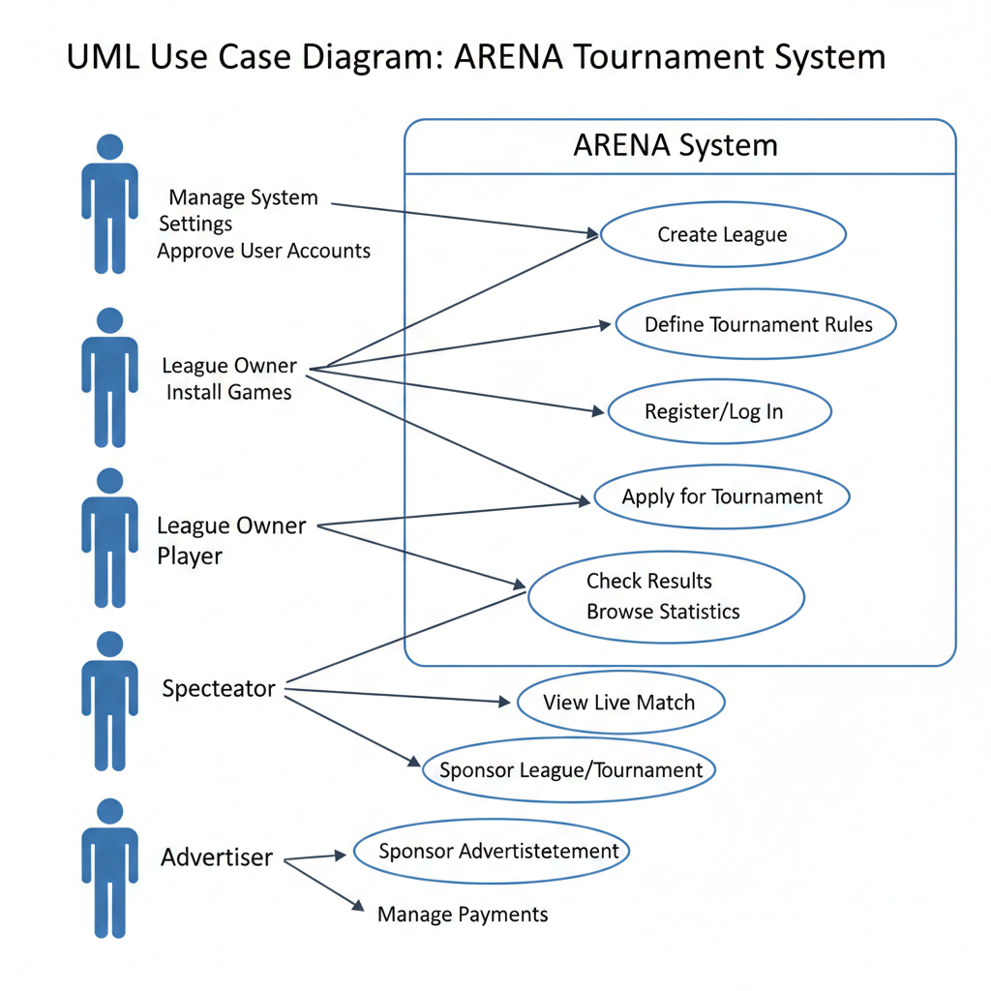

7.4 Class Design
The major classes identified in the ARENA system include: - User (base class) - Operator, LeagueOwner, Player, Spectator, Advertiser (derived classes) - League - Tournament - Match - Game - Advertisement Each class encapsulates attributes and methods relevant to its responsibilities.
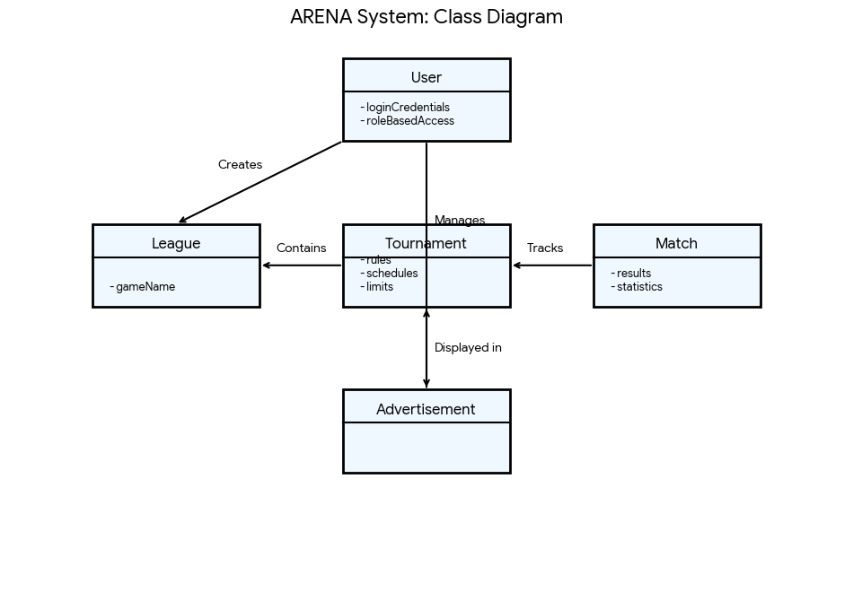

7.5 Sequence Design
Sequence design explains the interaction between system components over time. In ARENA, sequence diagrams describe how actors and system objects collaborate to perform specific tasks.
Key sequence scenarios include: - Tournament Announcement Sequence: A League Owner creates a tournament, the system checks constraints, contacts advertisers for sponsorship, and notifies interested users. - Player Application Sequence: A Player applies for a tournament, the system validates eligibility, and the application is stored for scheduling. - Match Execution Sequence: Players join a match, the game engine controls the match flow, results are recorded, and statistics are updated.
These sequences ensure correct ordering of operations and smooth coordination among system modules.
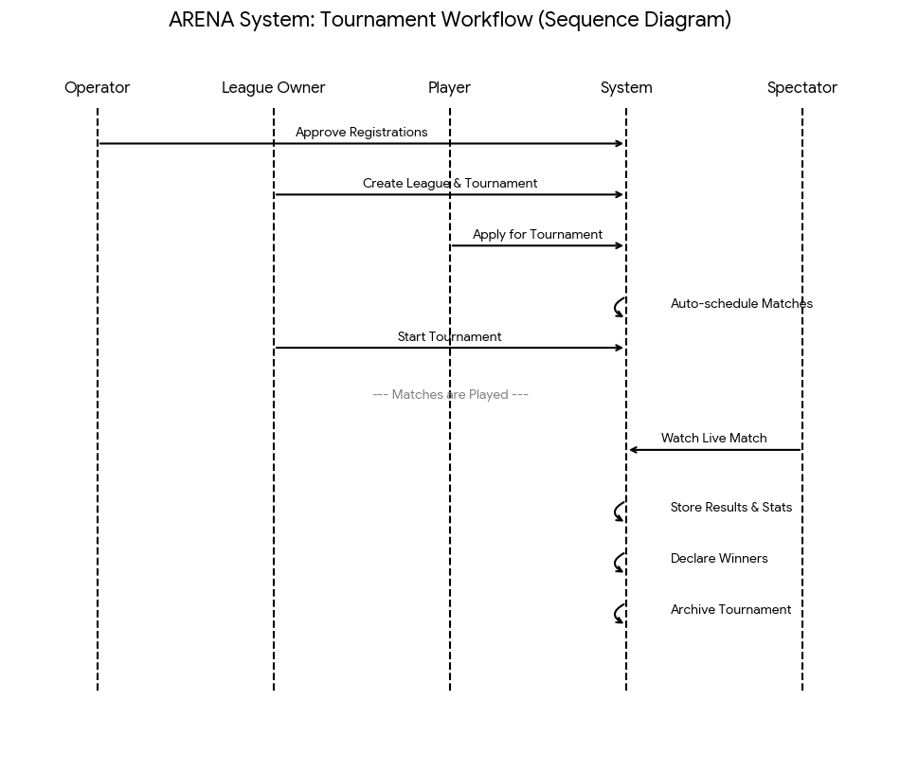

7.6 Database Design
The ARENA system uses a centralized relational database to store and manage system data. The database ensures data consistency, integrity, and efficient retrieval.
Major database entities include: - User (UserID, Name, Email, Role) - League (LeagueID, Name, GameType) - Tournament (TournamentID, Name, Dates, LeagueID) - Match (MatchID, TournamentID, Players, Result) - Game (GameID, Rules, Type) - Advertisement (AdID, AdvertiserID, Cost)
Relationships are defined using primary and foreign keys. This design supports scalability and easy maintenance.

7.7 User Interface Design
The ARENA user interface is web-based and role-specific. Each user type interacts with the system through customized screens.
- Operator Interface: System configuration, user approval, and game management dashboards.
- League Owner Interface: League creation, tournament management, and player scheduling screens.
- Player Interface: Registration, tournament application, and match participation views.
- Spectator Interface: Live match viewing, statistics browsing, and replay options.
- Advertiser Interface: Advertisement upload, sponsorship selection, and billing overview.
The interface is designed to be simple, intuitive, and responsive.

7.8 Security Design
Security is a critical aspect of the ARENA system. The system implements role-based access control to restrict unauthorized actions.
Security features include: - Secure login and authentication for registered users - Authorization based on user roles (Operator, League Owner, Player, Advertiser) - Protection of sensitive data such as advertiser billing information - Secure communication using HTTPS
These measures ensure data confidentiality and system integrity.

7.9 Design Constraints
The ARENA system design is subject to the following constraints: - The system must be accessible through a web browser only - Deployment is limited to Unix-based operating systems - The system must support low-bandwidth network connections - New games and tournament styles must be added without modifying existing system components
These constraints influence design decisions and implementation strategies.

